Lecture 3

Q1.Look at these sentence starters. Try to start a conversation using one or two of these expressions. Use your imagination to compose a dialogue between you and a friend, brother, or any one you like or dislike.

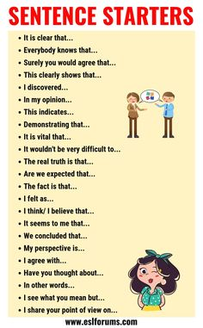

2. Imagine yourself in this boat instead of this young man. What will you do.
